Week7_Using React Context API for Employee Theme Sharing (employeesapp)

Objective:

Developers of Apps Centric Solutions have created an employee management application which supports light and dark themes for the buttons. The current solution uses the react state and props to provide the theme name to be used from App component to Employee List component and from there to Employee Card component. Quality assurance team analyzed the solutions and found the technique being used to be a substandard one. React architect suggested to use the react context API to share the theme name with nested child components instead of passing them down using props from the parent component.

Phase 1: Setting Up Your Development Environment
Step 1: Install Node.js and npm
- Explanation: Node.js is a JavaScript runtime that lets you run JavaScript on your computer. npm is the package manager for Node.js, used to install and manage project dependencies like React.
- Action:
- Open a web browser and navigate to the official Node.js download page: https://nodejs.org/en/download/
Step 2: Install Visual Studio Code
- Explanation: Visual Studio Code (VS Code) is a free, powerful code editor that is highly recommended for React development.
- Action:
- Go to the official VS Code website: https://code.visualstudio.com/
- Download and run the installer for your operating system.

Phase 2: Creating and Running the React Application
Step 3: Install Dependencies
- In your command prompt or terminal, navigate to the directory where you want to store your project (e.g., your Desktop or a development folder).
- Type the following command and press Enter. This may take a few minutes to complete.
npm install
Step 4: Navigate into Your New Project Folder
- You must be inside the project folder to run commands related to this specific application.
- Once the command from Step 4 is finished, type the following command to move into the newly created directory:
cd employeesapp
Step 5: Open the Project in Visual Studio Code
- This command opens the entire project folder in VS Code, allowing you to easily browse and edit the project files.
- Type the command:
code . //Note: The . tells VS Code to open the current directory.

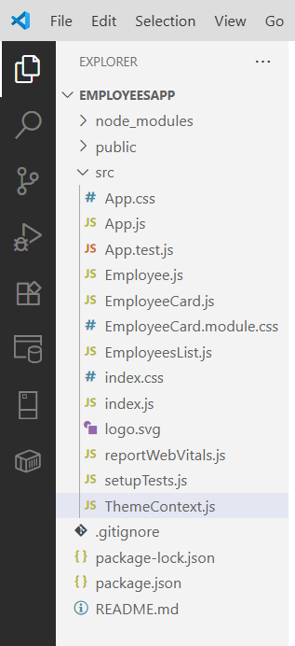
Step 6: Create Context File: ThemeContext.js
- In the VS Code explorer, right-click the src folder.
- Select "New File" and name it ThemeContext.js.
// ThemeContext.js
import React from 'react';
const ThemeContext = React.createContext('dark');
export default ThemeContext;
Step 7: Edit the Main App.js File
- Open the App.js file from the src folder.
- Replace all of its content with this code:
// App.js
import React, { useState } from 'react';
import EmployeesList from './EmployeesList';
import ThemeContext from './ThemeContext';
function App() {
const [theme, setTheme] = useState('light');
return (
<ThemeContext.Provider value={theme}>
<div>
<h1>Employee Management</h1>
<EmployeesList />
</div>
</ThemeContext.Provider>
);
}
export default App;
Step 8: Edit the Main EmployeesList.js File
// EmployeesList.js
import React from 'react';
import EmployeeCard from './EmployeeCard';
function EmployeesList() {
const employees = [
{
id: 1,
name: 'Alice Johnson',
doj: '2021-04-05',
email: 'alice.johnson@cognizant.com',
position: 'Software Engineer',
},
{
id: 2,
name: 'Michael Smith',
doj: '2020-08-12',
email: 'michael.smith@cognizant.com',
position: 'UI/UX Designer',
},
{
id: 3,
name: 'Priya Verma',
doj: '2022-01-18',
email: 'priya.verma@cognizant.com',
position: 'Data Analyst',
},
];
return (
<div>
<h2>Employee Details</h2>
{employees.map((emp) => (
<EmployeeCard key={emp.id} emp={emp} />
))}
</div>
);
}
export default EmployeesList;

Step 9: Edit the Main EmployeeCard.js File
// EmployeeCard.js
import React, { useContext } from 'react';
import ThemeContext from './ThemeContext';
function EmployeeCard({ emp }) {
const theme = useContext(ThemeContext);
const cardStyle = {
padding: '10px',
margin: '10px',
border: `2px solid ${theme === 'dark' ? 'white' : 'black'}`,
backgroundColor: theme === 'dark' ? '#333' : '#f0f0f0',
color: theme === 'dark' ? 'white' : 'black',};
return (
<div style={cardStyle}>
<h3>{emp.name}</h3>
<p><strong>Position:</strong> {emp.position}</p>
<p><strong>Email:</strong> {emp.email}</p>
<p><strong>Date of Joining:</strong> {emp.doj}</p>
</div>
);
}
export default EmployeeCard;
Step 10: Run the Application
- Go back to your terminal (it should still be in the employeesapp folder).
- Run the start command:
npm start

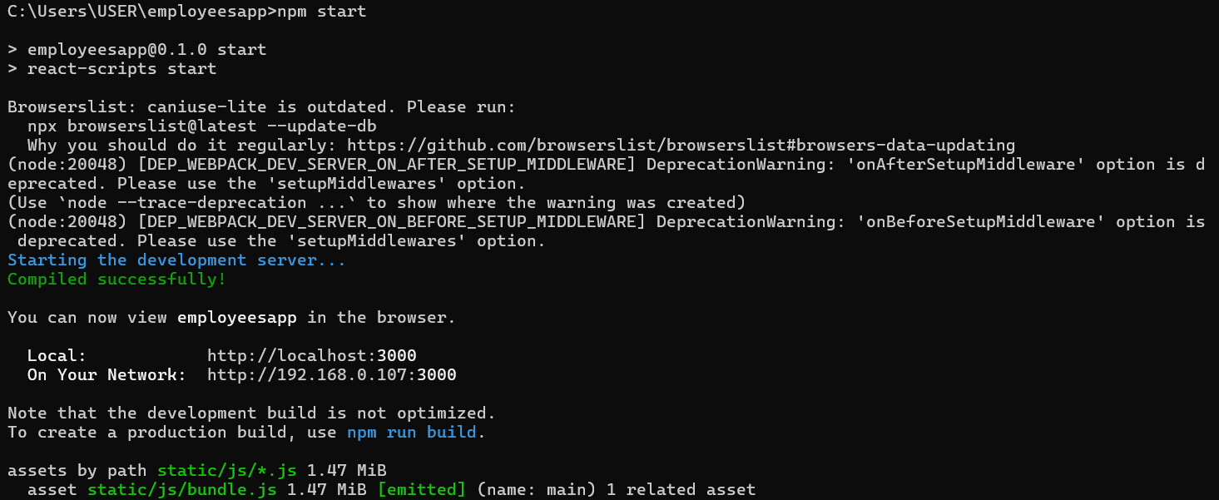
Step 11: View Your Application
- The development server hosts your application on a local port, typically 3000.
Local: http://localhost:3000
On Your Network: http://192.168.0.107:3000

Output:

